**Lesson 3 Reports II**

**Lesson objectives:**

* Learn how to write descriptive reports of academic articles.
* Learn how to write compositional reports of academic articles.
* Learn how to use proper expressions in writing descriptive reports.

**1. Review**

**1.1 Three types of reports**

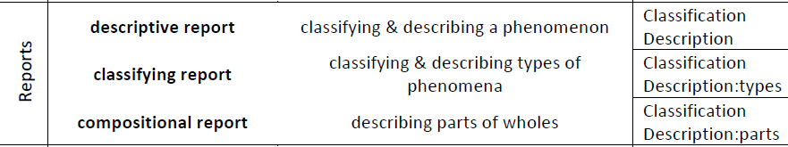

**1.2 The structure of classifying reports**

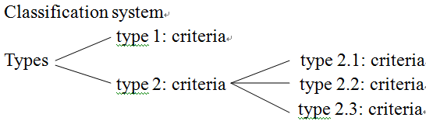

**1.3 One more sample text:**

Please analyze the structure of the following text.

**The Indochina Wars**

There were three Indochina Wars: the first war to remove the French; the second, the North Vietnamese campaign to unify the country; and the third, the clashes between Vietnam, Cambodia and China. All three wars saw massive loss of life and social and economic dislocation within the region. The period marked the end of western imperialism and forced the USA to acknowledge that there were limits, even as a superpower, to its capacity to determine the fate of other nations.

**First Indochina War**

The First Indochina War was fought in French Indochina from December 19, 1946, until August 1, 1954…

**Vietnam War**

Various names have been applied what is known as the Vietnam War. These have shifted over time, although Vietnam War is the most commonly used title in English. It has been variously called…

**Sino-Vietnam War**

The Sino-Vietnam War…also known as the third Indochina War, known in the PRC as Counterattack against Vietnam in Self-Defense… was a brief but bloody border war fought in 1979 between the People’s Republic of China and the Socialist Republic of Vietnam.

**2. Descriptive reports**

Purpose: to classify and describe a phenomenon.

Stages: Classification + Description

**Sample Text 1: Goanna**

Australia is home to 25 of the world’s 30 monitor lizard species. In Australia, monitor lizards are called goannas. Goannas have flattish bodies, long tails and strong jaws. They are the only lizards with for ked tongues, like a snake. Their necks are long and may have loose folds of skin beneath them. Their legs are long and strong, with sharp claws on their feet. Many goannas have stripes, spots and other markings that help to camouflage them. The largest species can grow to more than two meters in length. All goannas are daytime hunters. They run, climb and swim well. Goannas hunt small mammals, birds and other reptiles. They also eat dead animals. Smaller goannas eat insects, spiders and worms. Male goannas fight with each other in the breeding season. Females lay between two and twelve eggs.

**Sample Text 2: Ergonomics**

Ergonomics (人体工程学) can be defined as the design of work so that the best is made of human capabilities without exceeding human limitations.

Standards Association of Australia, *Australian Standard*

*1837-1976: Ergonomics in Factory and Office Work*,

Standards Australia, North Sydney, 1976.

The evolution of a product or design based on ergonomics relates the product or design to the physical needs of the user. These physical needs include not only size and position but other aspects such as floor surfaces, illumination levels, hand grips, switch standards and vision.

Understanding the physical needs of the user allows the designer to cater for individual differences and to create products that cater for the needs of the majority of consumers. Ergonomics is to do with the human body as a whole but it also involves the function of parts of the body and the ease with which humans perform simple tasks.

**3. Expressions in descriptive reports**

The tables below show some of the most common expressions used in texts which describe position, weight, structure, color, composition, size, shape and function.

**Position**

|  |  |  |
| --- | --- | --- |
| A is | adjacent to alongside below beyond facing (diagonally)  parallel to underneath opposite in the middle of on the right of on the left of near close to touching behind in front of under on top of above below level with diagonally above vertically below | B |
| between equidistant from | B and C. |

**Structure**

|  |  |  |  |  |  |  |
| --- | --- | --- | --- | --- | --- | --- |
| X | is | nailed screwed fixed fastened linked welded tied connected attached | to | Y | by | Z |
| consists | | of | Y and Z | | |
| contains includes | | |
| is | held in place secured supported suspended | by | Y | | |
| joined | to |
| mounted placed pivoted | on |

**Color**

|  |  |  |  |
| --- | --- | --- | --- |
| X | is | dark light pale bright dull | green. blue. red. yellow. |

**Composition**

|  |  |  |  |
| --- | --- | --- | --- |
| X | is | made of | metal. steel. aluminium. an alloy of A and B. cloth. silk. china. wood. plastic. glass. |

**Size and weight**

|  |  |  |  |
| --- | --- | --- | --- |
| X | is | 6 cm | long high wide |

|  |  |  |  |  |
| --- | --- | --- | --- | --- |
| X | is | 6 cm | in | length height width diameter |
| 6 Kg | weight |

|  |  |  |  |  |  |
| --- | --- | --- | --- | --- | --- |
| The | length height width diameter | of | X | is | 6 cm |
| weight | 6 kg. |

|  |  |  |  |  |  |
| --- | --- | --- | --- | --- | --- |
| X | has | a | length width height diameter | of | 6 cm. |
| weight | 6 kg. |

|  |  |  |
| --- | --- | --- |
| X | weighs | 10 Kg |

**Shape**

|  |  |  |  |
| --- | --- | --- | --- |
| X | is | square round rectangular triangular semi-circular conical spherical hexagonal octagonal oval circular irregular | in shape |

|  |  |  |  |
| --- | --- | --- | --- |
| X | is | is shaped like a | square circle rectangle triangle semi-circle hexagon octagon |

|  |  |  |  |
| --- | --- | --- | --- |
| X | is | cubical cylindrical pyramidal spherical tubular spiral hemispherical conical | in shape |

|  |  |  |  |
| --- | --- | --- | --- |
| X | is | bulbous tapering concave convex | in shape. |
| diamond-shaped kidney-shaped U-shaped star-shaped bell-shaped dome-shaped mushroom-shaped X-shaped crescent-shaped egg-shaped pear-shaped Y-shaped | . |

**Function**

|  |  |  |  |  |  |
| --- | --- | --- | --- | --- | --- |
| The | function purpose aim objective | of the | thermometer tripod | is to | measure the temperature. hold the beaker. |

|  |  |  |  |
| --- | --- | --- | --- |
| The | thermometer tripod | is used for | measuring the temperature. holding the beaker, |

**Properties**

|  |  |
| --- | --- |
| X is | light |
| tough |
| soft |
| elastic |
| malleable |
| flexible |
| soluble |
| a good conductor of electricity/heat |
| corrosion resistant |
| combustible |
| transparent |
| smooth |
| heavy |
| brittle |
| hard |
| plastic |
| ductile |
| rigid |
| insoluble |
| a bad conductor of electricity/heat |
| not corrosion resistant |
| non-combustible |
| opaque |
| rough |

**4. Compositional reports**

Compositional reports are concerned with parts of the whole.

Stages: Classification of entity + Components (activities/functions within the whole) (+ Definition)

Patterns: ①　component-&-activity; ②　structure-&-function

**Sample Text 3**

**Mangroves: part of a community**

When you walk into a mangrove forest, you may at first think that grey mangroves are the only living organisms there. However, look and listen and you will find evidence of other living occupants of the forest.

Many different kinds of organisms share the living space with the grey mangroves. Fish and shrimp are found in the brackish waters. At low tide, you may notice small crabs scurrying into burrows in the mud. Even if you miss the crabs you will see evidence of their presence from holes in the mud leading to their burrows.

At low-tide periods, various mollusks, such as snails and whelks, graze on algae that form a green film on parts of the muddy forest floor. Spiders spin their webs between branches of the grey mangroves to catch passing insects. Lichens grow on the trunks of mature mangrove trees. Many bird species feed on the nectar and pollen of the mangrove flowers and on the insects that live in the mangrove trees. At low tide, mudflats on the deepwater side of the mangrove forests are feeding sites for other bird species, such as the striated heron, Ardeola striatus, that feeds on snails and crabs. All these different kinds of organisms are part of the living community of the mangrove forest.

**Sample Text 4: Transport in the body**

Transport systems are need inside the body of all living things. In humans the blood or circulatory system carries digested food and other materials around the body. The blood contains 20 billion tiny cells floating in a liquid called plasma. The cells are of two different kinds red cells which carry oxygen and white cells which attack germs. Platelets which are microscopic discs, help in blood clotting.

Red blood cells are made in bone marrow. They live for about 100 days and then they are destroyed by the liver. The bone marrow makes new cells to replace the destroyed cells. White blood cells protect the body against toxins and infections.

The chemicals into which food has been broken-down are carried to all the body’s cells in the blood. Blood also carries waste away from the cells.

The blood moves through a series of tubes called blood vessels. The tubes could be compared with the road network of a country. However there are no head-on crashes as the tubes are strictly one-way.

Blood is pumped around the body by the heart. Tubes called arteries carry blood away from the heart. Except for the artery to the lungs they carry bright red blood, rich in oxygen. Tubes called veins bring blood back to the heart. Except for the vein from the lungs they carry dark red blood short of oxygen. The smallest arteries and veins are linked by tiny tubes called capillaries. Through their fine walls, oxygen and the chemicals from food are delivered to the cells all over the body, and waste products are collected.

**5. In-class practice**

**Exercise 1:** Analyze the following descriptive report. You may refer to the analysis of Sample Text 1 and label the stages (classification, description) and phases (characteristics of the octopus), and underline the key elements.

**Octopus**

An octopus is an ocean dwelling mollusk in the [cephalopod](http://www.wisegeek.com/what-is-a-cephalopod.htm)(头足纲) class. As the name suggests, the primary feature of an octopus is eight highly mobile arms, attached to a central bulbous body. Its head is soft and rubberlike. Its eyes stick out on stalks so that it can see in all directions. Its mouth is on the underside of its body and has powerful jaws shaped like a beak. The long arms, or tentacles (触角), have double rows of suckers. These can fasten onto objects with such suction that they cannot be pulled off. Octopi can be found in all the oceans of the world, typically dwelling in shallow water, preferring the ocean floor as a habitat. In addition to serving as a food source, the octopus is also studied by many scientists, as it is believed to be the most intelligent of the invertebrates (无脊椎动物). The animals demonstrate an immense capacity for learning, logic, and reasoning, especially in controlled environments.

**Exercise 2:** Examine the illustration below. What system is illustrated? What function(s) does it have? What are its components, and what functions do they have? Analyze the following compositional report. You may refer to the analysis of Sample Text 3 and classify the atom with its function(s), and give its components. Please label the stages (classification of entity, components, definition) and underline the components of the entity.

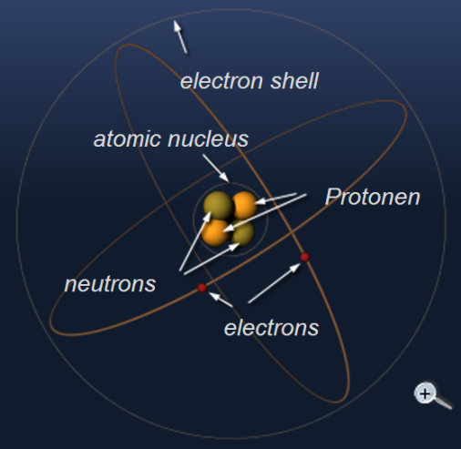

(Retrieved September 21, 2017, from the World Wide Web: http://www.radartutorial.eu/21.semiconductors/hl04.en.html)

**Atomic Structure**

Atoms are the units for elements. The atom is basically composed of electrons, protons, and neutrons. The electrons, protons, and neutrons of one element are identical to those of any other element. There are different kinds of elements because the number and the arrangement of electrons and protons are different for each element. The electron carries a small negative charge of electricity. The proton carries a positive charge of electricity equal and opposite to the charge of the electron. Both the electron and proton have the same quantity of charge, although the mass of the proton is approximately 1,827 times that of the electron. In some atoms there exists a neutral particle called a neutron. The neutron has a mass approximately equal to that of a proton, but it has no electrical charge. According to theory, the electrons, protons, and neutrons of the atoms are thought to be arranged in a manner similar to a miniature solar system. Notice the helium atom in the figure. Two protons and two neutrons form the heavy nucleus with a positive charge around which two very light electrons revolve. The path each electron takes around the nucleus is called an orbit. The electrons are continuously being acted upon in their orbits by the force of attraction of the nucleus. To maintain an orbit around the nucleus, the electrons travel at a speed that produces a counterforce equal to the attraction force of the nucleus. The orbiting electrons do not follow random paths, instead they are confined to definite energy levels. Visualize these levels as shells with each successive shell being spaced a greater distance from the nucleus.

**Exercise 3:** Write a compositional report of the following creature—an insect. Please label each stage with “Classification of entity”, “Components”, and “Definition”. Remember to give the name and location of each part alongside with its activities/function within the whole.

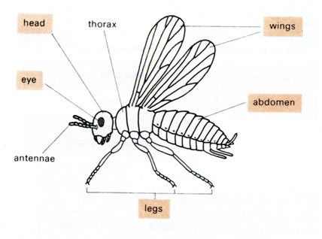

**Exercise 4:** Write a descriptive report of the lynx. Refer to the Analysis of Sample Text 1 and Exercise 1. Remember to label the stages (classification, description) and phases (characteristics of the lynx), and underline the key elements. Your report should have 150-200 words.

Lynx

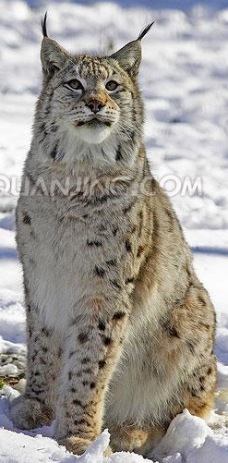

**References:**

Martin, J. R., and Rose, D. (2008). *Genre Relation, Mapping Culture*. Equinox Publishing Ltd.